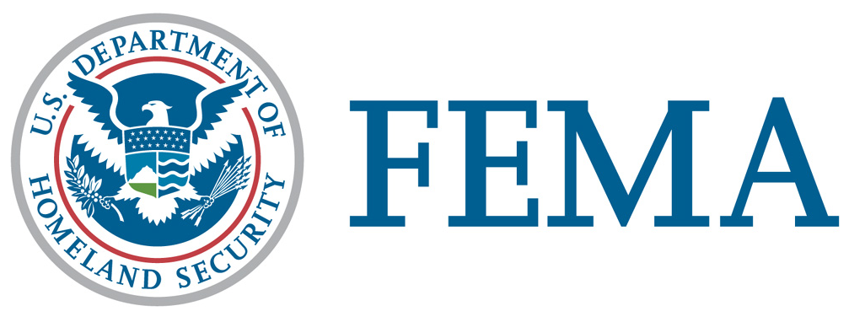

Legislative Affairs Division

FEMA Public Assistance

The Federal Emergency Management Agency (FEMA), which is now incorporated within the Department of Homeland Security, under the authority of the Robert T. Stafford Disaster Relief and Emergency Assistance Act (Stafford Act), Public Law 93-288, as amended, administers the Public Assistance (PA) program. Public Assistance is oriented to public entities and can fund the repair, restoration, reconstruction, or replacement of a public facility or infrastructure, which is damaged or destroyed by a disaster.
Eligible applicants include State governments, local governments and any other political subdivision of the State, Native American tribes, and Alaska Native Villages. Certain private nonprofit (PNP) organizations may also receive assistance. Eligible PNPs include educational, utility, irrigation, emergency, medical, rehabilitation, and temporary or permanent custodial care facilities (including those for the aged and disabled), and other PNP facilities that provide essential services of a governmental nature to the general public. PNPs that provide “critical services” (power, water--including water provided by an irrigation organization or facility, sewer, wastewater treatment, communications, educational services, and emergency medical care) may apply directly to FEMA for a disaster grant. All other PNPs must first apply to the Small Business Administration (SBA) for a disaster loan. If the PNP is declined for an SBA loan, or the loan does not cover all eligible damages, the applicant may re-apply for FEMA assistance.

As soon as practicable after the declaration, the State, assisted by FEMA, conducts the Applicant Briefings for State, local and PNP officials to inform them about the assistance available and how to apply for it. A request for Public Assistance must be filed with the State within 30 days after the area is designated eligible for assistance. Following the Applicant’s Briefing, a Kickoff Meeting is conducted where damages will be discussed, needs assessed, and a plan of action put in place. A combined Federal/State/local team proceeds with Project Formulation, which is the process of documenting the eligible facility, the eligible work, and the eligible cost for fixing the damages to every public or PNP facility identified by State or local representatives. The team prepares a Project Worksheet (PW) for each project. Projects fall into the following categories:

- Category A: Debris removal
- Category B: Emergency protective measures
- Category C: Road systems and bridges
- Category D: Water control facilities
- Category E: Public buildings and contents
- Category F: Public utilities
- Category G: Parks, recreational, and other

For insurable structures within special flood hazard areas (SFHA), primarily buildings, assistance from FEMA is reduced by the amount of insurance settlement that could have been obtained under a standard NFIP policy. For structures located outside of a SFHA, FEMA will reduce the amount of eligible assistance by any available insurance proceeds.

FEMA reviews and approves the PWs and obligates the Federal share of the costs (which cannot be less than 75 percent) to the State. The State then disburses funds to local applicants.

Projects falling below a certain threshold are considered ‘small.’ The threshold is adjusted annually for inflation. For fiscal year 2011, that threshold is $63,900. For small projects, payment of the Federal share of the estimate is made upon approval of the project, and no further accounting to FEMA is required. For large projects, payment is made on the basis of actual costs determined after the project is completed, although interim payments may be made as necessary. Once FEMA obligates funds to the State, further management of the assistance, including disbursement to subgrantees, is the responsibility of the State. FEMA will continue to monitor the recovery progress to ensure the timely delivery of eligible assistance and compliance with the law and regulations.

