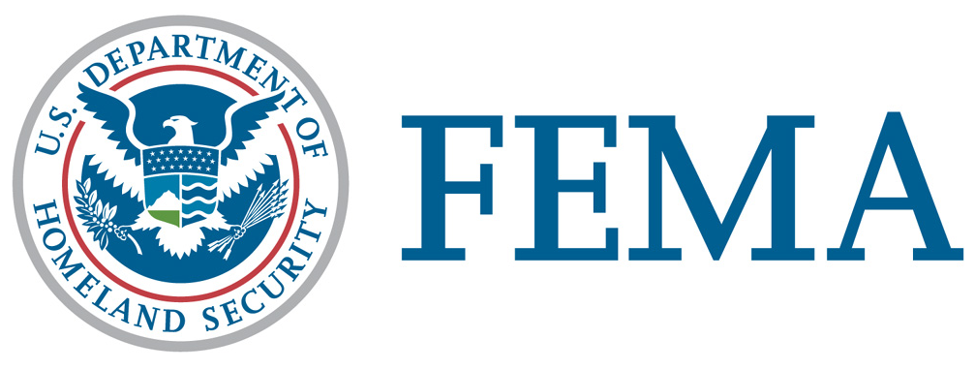

Legislative Affairs Division

ASSISTANCE TO INDIVIDUALS AND HOUSEHOLDS

The Individuals and Households Program (IHP) provides financial help or direct services to those who have necessary expenses and serious needs if they are unable to meet the needs through other means. Up to $30,200 is available in financial help (adjusted each year), although some forms of IHP assistance have limits. Flood insurance may be required as indicated below. These forms of help are available: Housing Assistance (including Temporary Housing, Repair, Replacement, and Semi-Permanent or Permanent Housing Construction) and Other Needs Assistance (including personal property and other items).

Housing Assistance

Temporary Housing: Money to rent a different place to live or a temporary housing unit (when rental properties are not available).

Repair: Money for homeowners to repair damage from the disaster that is not covered by insurance. The goal is to repair the home to a safe and sanitary living or functioning condition. FEMA may provide up to $30,200 for home repair; then the homeowner may apply for a Small Business Administration disaster loan for additional repair assistance. FEMA will not pay to return a home to its condition before the disaster. Flood insurance may be required if the home is in a Special Flood Hazard Area. Repair and replacement items include:

- Structural parts of a home (foundation, outside walls, roof)
- Windows, doors, floors, walls, ceilings, cabinetry
- Septic or sewage system
- Well or other water system
- Heating, ventilating, and air conditioning system
- Utilities (electrical, plumbing, and gas systems)
- Entrance and exit ways from the home, including privately owned access roads
- Blocking, leveling and anchoring of a mobile home and reconnecting or resetting its sewer, water, electrical and fuel lines and tanks

Replacement: Money to replace a disaster-damaged home, under rare conditions, if this can be done with limited funds. FEMA may provide up to $30,200 for home replacement. If the home is located in a Special Flood Hazard Area, the homeowner must comply with flood insurance purchase requirements and local flood codes and requirements.

Semi-Permanent or Permanent Housing Construction: Direct assistance or money for the construction of a home. This type of assistance occurs only in very unusual situations, in locations specified by FEMA, where no other type of housing assistance is possible. Construction shall follow current minimal local building codes and standards where they exist, or minimal acceptable construction industry standards in the area. Construction will aim toward average quality, size, and capacity, taking into consideration the needs of the occupant. If the home is located in a Special Flood Hazard Area, the homeowner must comply with flood insurance purchase requirements and local flood codes and requirements.

Other Needs Assistance

Other Needs Assistance provision of the Individuals and Households Program provides grants for uninsured, disaster-related necessary expenses and serious needs. Flood insurance may be required on insurable items (personal property) if they are to be located in a Special Flood Hazard Area. Assistance includes:

- Medical and dental expenses
- Funeral and burial costs
- Repair, cleaning, or replacement of:
  - Clothing
  - Household items (room furnishings, appliances)
  - Specialized tools or protective clothing and equipment required for your job
  - Necessary educational materials (computers, school books, supplies)
- Clean-up items (wet/dry vacuum, air purifier, dehumidifier)
- Fuel (fuel, chain saw, firewood)
- Repairing or replacing vehicles damaged by the disaster, or providing for public transportation or other transportation costs
- Moving and storage expenses related to the disaster (including evacuation, storage, or the return of property to a home)
- Other necessary expenses or serious needs (for example, towing, or setup or connecting essential utilities for a housing unit not provided by FEMA)
- The cost of a National Flood Insurance Program group flood insurance policy to meet the flood insurance requirements

Conditions and Limitations of IHP Assistance

- Non-discrimination: All forms of FEMA disaster housing assistance are available to any affected household that meets the conditions of eligibility. No Federal entity or official (or their agent) may discriminate against any individual on the basis of race, color, religion, sex, age, national origin, disability, or economic status.

- Residency status in the United States and its territories: To be considered for disaster housing assistance, you or a household member must provide proof of identity and sign a declaration stating that you/they are a United States citizen, a non-citizen national, or a qualified alien.

- Supplemental Assistance: Disaster housing assistance is not intended to substitute for private recovery efforts, but to complement those efforts when needed. FEMA expects minor housing damage or the need for short-term shelter to be addressed by homeowners or tenants. Furthermore, the Disaster Housing Program is not a loss indemnification program and does not ensure that applicants are returned to their pre-disaster living conditions.

- Household Composition: People living together in one residence before the disaster are expected to continue to live together after the disaster. Generally, assistance is provided to the pre-disaster household as a unit. If, however, the assistance provided to the household is not shared with you, or if the new residence is too small or causes you undue hardship, you may request assistance separate from your pre-disaster household.

- Type of Assistance: Generally, more than one type of IHP assistance may be provided to the household. Only FEMA has the authority to determine which type of assistance is most appropriate for the household and the period of assistance to be covered.

- Proper Use of Assistance: All financial assistance provided by FEMA should be used as specified in writing: to rent another place to live, to make the home repairs identified by FEMA, or to prevent eviction or foreclosure, or to replace or repair personal property. Failure to use the money as specified may make you ineligible for additional assistance. All money provided by FEMA is tax-free.

- Documentation: It is your responsibility to provide all documentation necessary for FEMA to evaluate your eligibility. You may need to provide proof of occupancy, ownership, income loss, and/or information concerning your housing situation prior to the disaster. You should keep all receipts and records for any housing expenses incurred as a result of the disaster. This includes receipts for repair supplies, labor, and rent payments.

- Insurance: If you have insurance, any assistance provided by FEMA should be considered an advance and must be repaid to FEMA when you receive your insurance settlement payment. If your settlement is less than FEMA’s estimated cost to make your home habitable, you may qualify for funds to supplement your insurance settlement, but only for repairs relating to the home’s habitability. FEMA does not provide replacement value amounts or assistance with non-essential items.

- Duration of Assistance: Repair and Replacement Assistance is provided as a one-time payment. Temporary Housing Assistance (or a mobile home/travel trailer) is provided for an initial period of 1, 2, or 3 months. To be considered for additional assistance, you must demonstrate that you have spent any previous assistance from FEMA as instructed, and you must demonstrate your efforts to re-establish permanent housing. Additional assistance is generally provided for 1, 2, or 3 months at a time. The maximum period for IHP assistance is 18 months, unless extended by the President.

- Appeal Rights: If you disagree with FEMA's determination of eligibility or the form of assistance provided, you have the right to appeal within 60 days of the date of your notification letter. Send appeal letters to: Appeals Officer, FEMA- Individuals & Households Program, National Processing Service Center, P.O. Box 10055, Hyattsville, MD 20782-7055. Telephone: 1-800-621-FEMA or TTY 1-800-462-7585.

